Appendix c

Android Fitness Application

Mohammed Miah

City, University of London

BSc. Computer Science

Contents

User Manual 2

Register 2

Homepage 4

Workouts 5

Diary 7

Add/Remove meals 9

Posts 10

Add a post 11

Workout Log 12

Personal Trainer Area 13

Settings 14

Contact Us 15

# User Manual

Once the application is downloaded, there are many features that you can explore. This user manual guides you through all the steps needed to create an account, and the features offered.

# Register

To use the app, you must create an account. This is a three-step process.

**Step 1** – Enter your account information such as your first name, last name, email address and password. See Figure C1

**Step 2** – Enter more information such as your age, weight, height, and gender. See Figure C2. You can change between imperial and metric for weight and height.

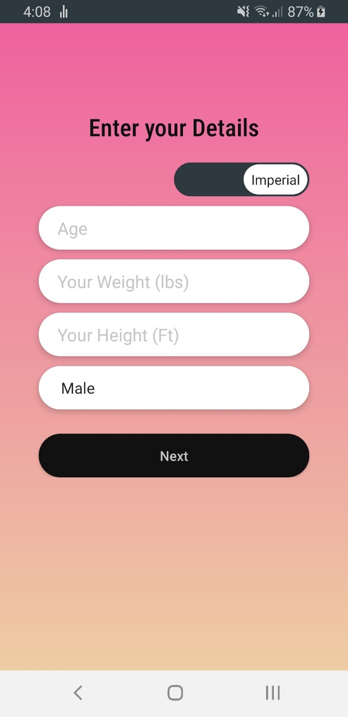Figure C1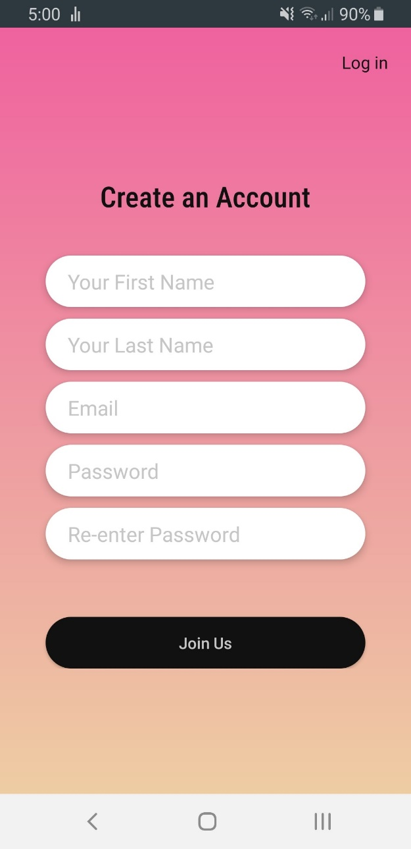

Figure C2

**Step** **3** – Finally enter what you want to gain from this app such as your goal, whether you want to lose weight, gain muscle or if you want to maintain your current weight. See Figure C3.

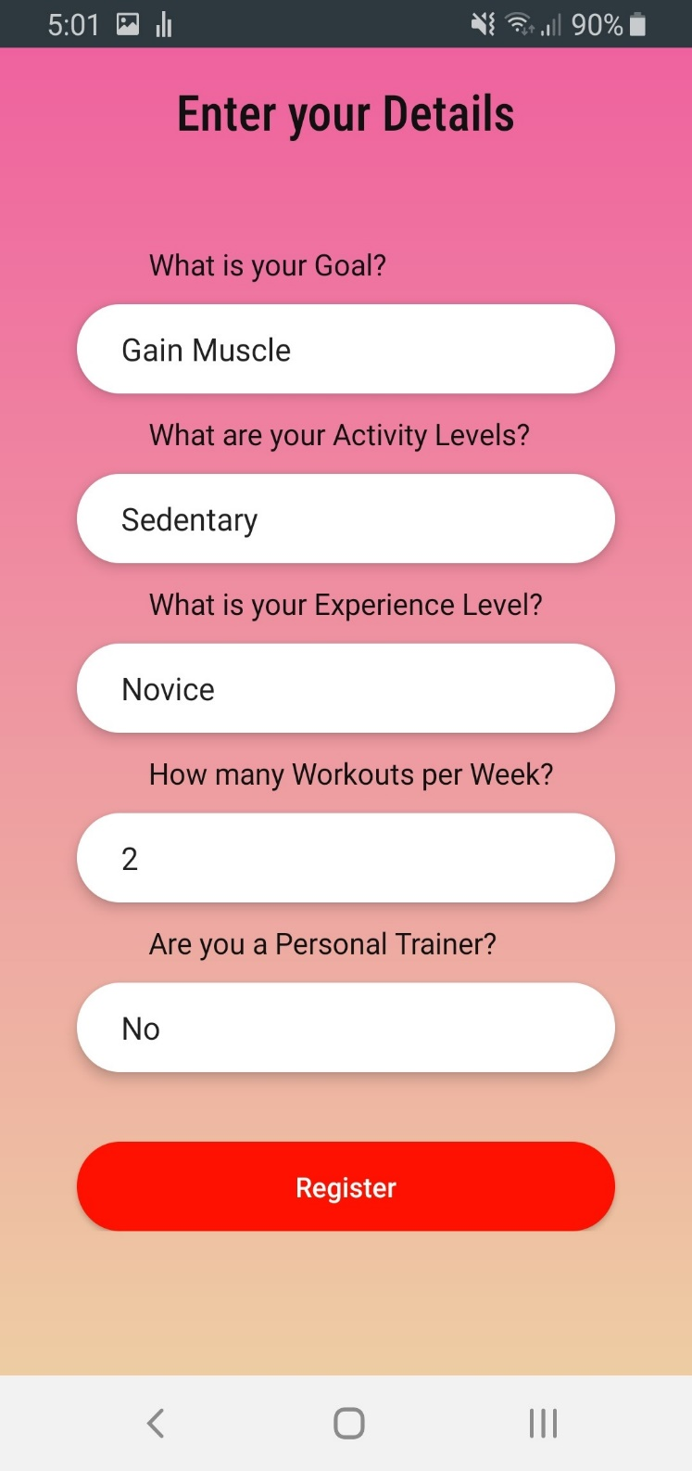Enter what is your activity levels like:

**Sedentary** – “Exercising is not part of my weekly routine”

**Lightly** **active** – “I hit the gym once or twice a week”

**Moderately** **active** – “I exercise fairly regularly, around 3-4 times a week”

**Very** **active** – “I work out 5-6 times a week”

**Super active** – “I work out all the time”

Enter your Experience levels:

**Novice** –“Never worked out”

**Beginner** –“less than 6 months of working out”

**Intermediate** –“1-3 years of gymexperience”

**Advanced** –“3+ years”

Enter **how many days** you are aiming to work out every week. This will determine how your workouts are managed.

Figure C3

And finally, enter yes if you are a **Personal trainer**.

A personal trainer account will grant you access to assign specialized workouts to your clients.

# Homepage

The homepage contains all the features of the app. See Figure C4

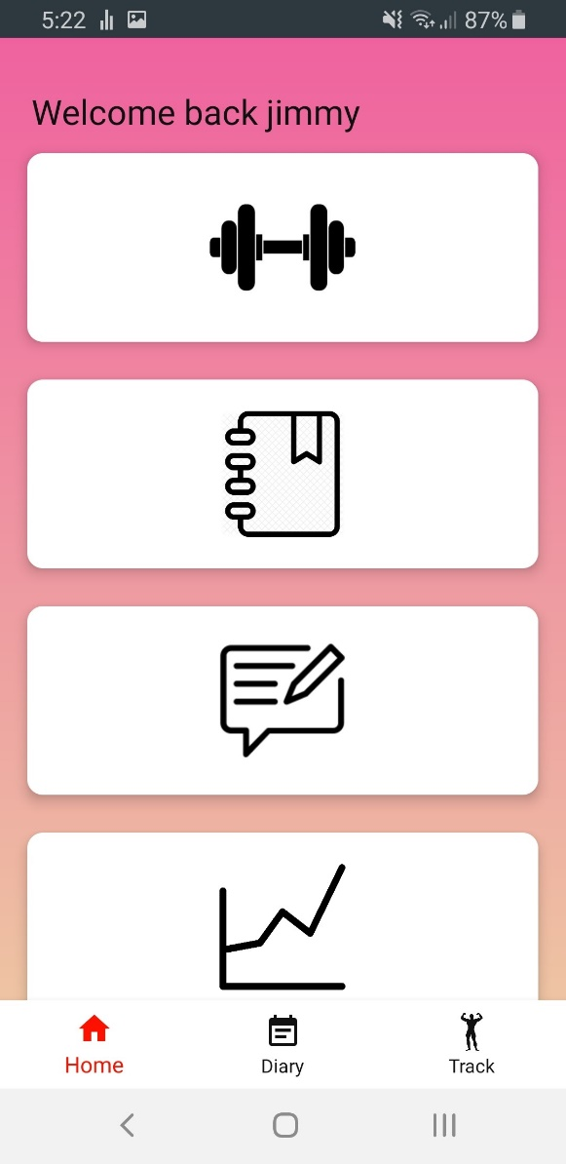

**View your workouts**

**Track your Macros with the Diary**

**View and add posts**

**to the blog to see**

**what the other**

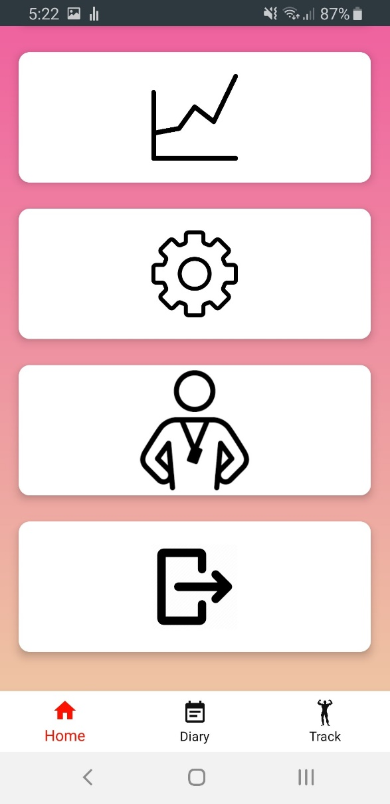**users have shared**

**Track your lifting. See how much strength you’ve gained**

**Use the settings tab to update your details, or to contact us**

**Personal trainer area. Assign specialized workout plans to your clients**

**Log out**

**Use this navigation bar to quickly traverse between common pages**

Figure C4

# Workouts

One of the integral components of the app is to follow the workout plans. Depending on the information you set to create an account, a specialized workout will be made for you. Once you’ve entered the workouts homepage, there is an overview of your workouts for the week, Figure C5. Then select a workout, and you will see all the exercises for the said workout, Figure C6.

Figure C5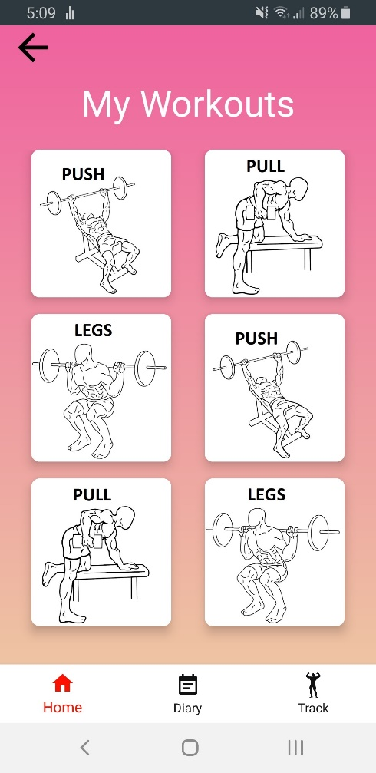

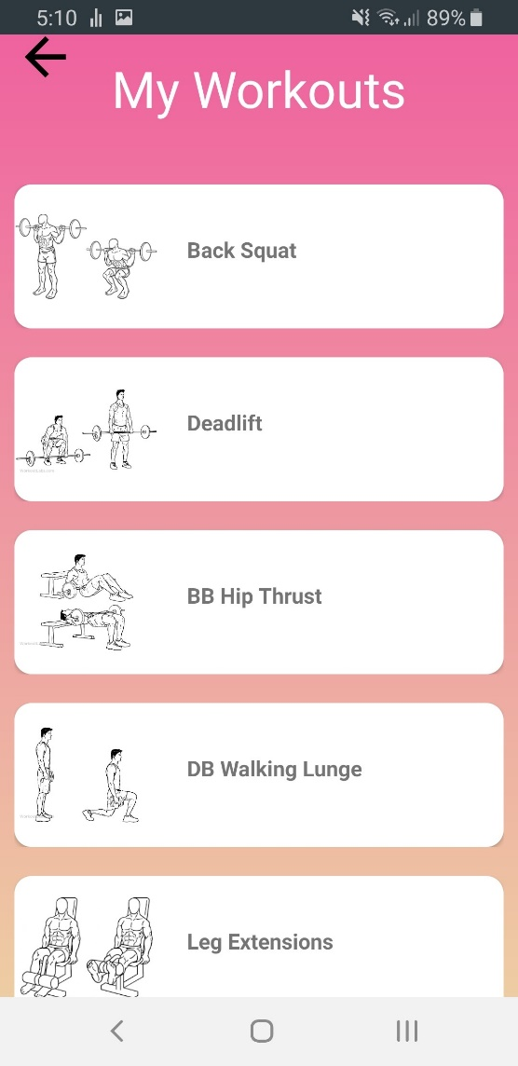

Figure C6

Once you select an exercise, you will be redirected to a screen with more information about the said exercise. See Figure C7.

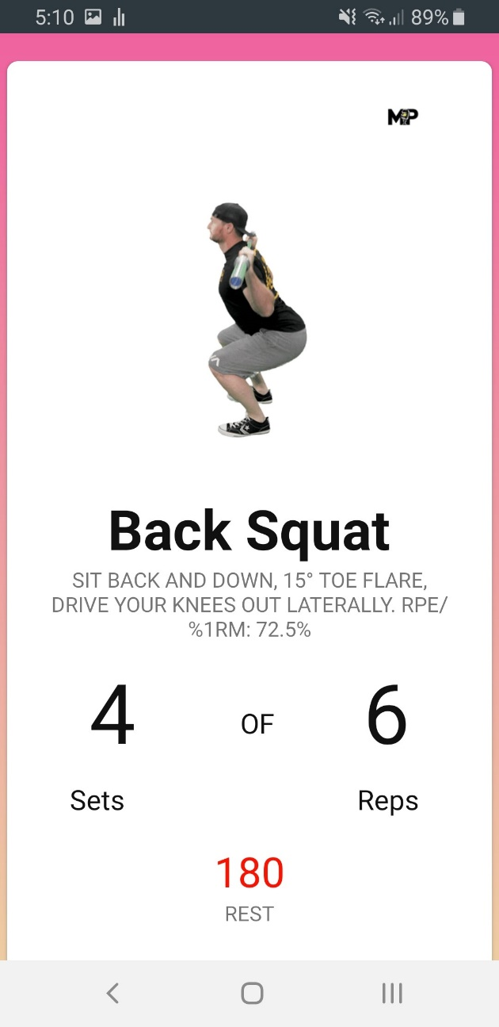

**A Gif to demonstrate the exercise**

**Click the Gif to view a full tutorial on how to execute the exercise.**

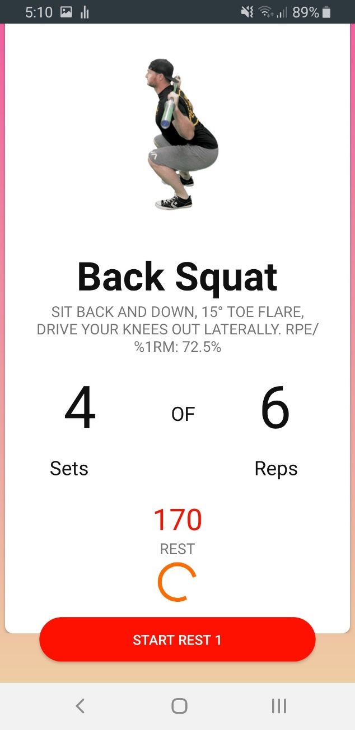

**How long your rest should be in seconds**

**Click this button when you start your rest for a timer**

Figure C7

# Diary

To track your macros for the day, you will need to use the diary feature. See Figure C8.

**Back button, return to the homepage**

**Start a new day. This will reset your macro allowance. Do this every morning so you can record your macros at the start of each day.**

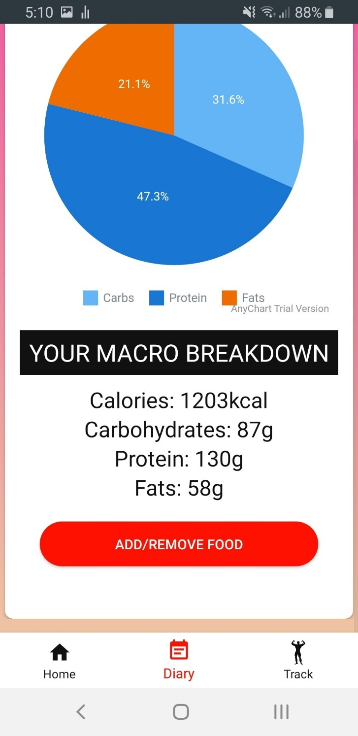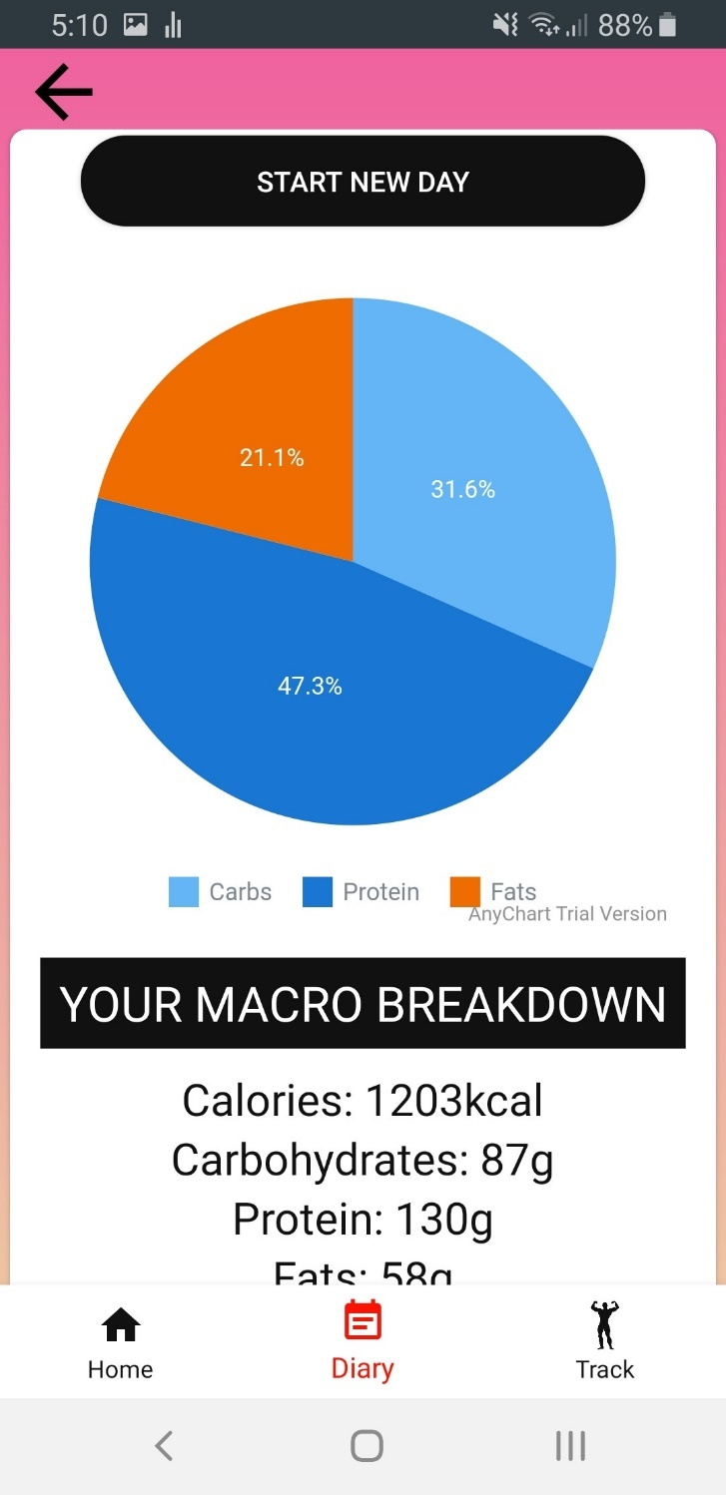

**Add or remove meals. See the next page.**

**How many calories, carbohydrates, protein and fats left to consume in the day to reach your target.**

**Interactive Pie chart. Click this to get a more in-depth view of your macro breakdown**

Figure C8

## Add/Remove meals

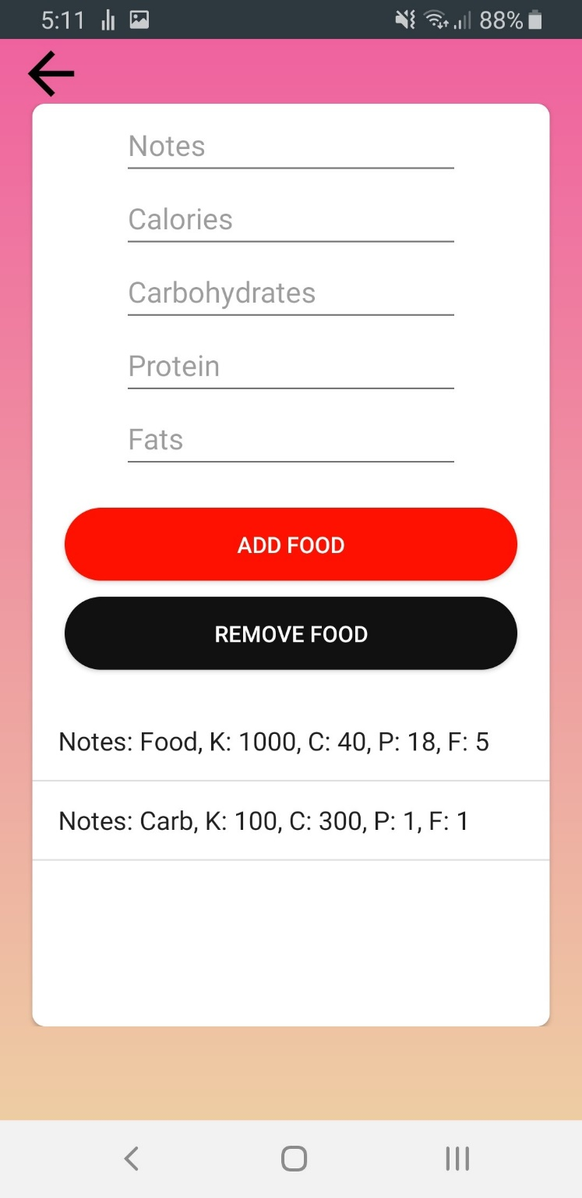See Figure C9 to learn how to add or remove meals.

**To remove a meal, input the name of the meal and select the Remove Food button.** *Note you can see the names all below.

**To add a meal, input the name of the meal, calories (Kcal), carbohydrates (g), protein (g) and fats (g). Then select the Add Food button.** *Note they must all have a value of at least 0.

**This will list all your meals for the day.**

**K = calories (Kcal), C = carbs (g),**

**P = protein (g),**

**F = fats (g)**

Figure C9

# Posts

The posts feature allows you to see what the community have to share. View posts and add a post yourself. SeeFigure C10

**These are all the posts in the community**

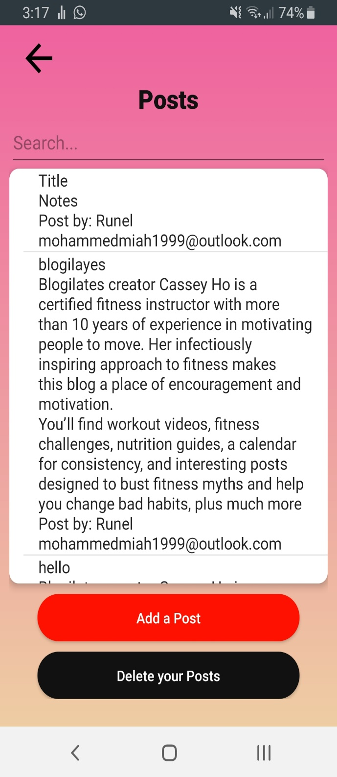

**Add a post of your own**

**Filter the posts through the search bar.**

**Select a post to contact, via email, the user who wrote the post**

**All posts contain the following:**

**Title of the post,**

**The contents of the post,**

**The user’s name who wrote the post,**

**Their email address**

**Delete all posts that you have added**

Figure C10

## Add a post

To add a post to the forum, fill out this form. See Figure C11.

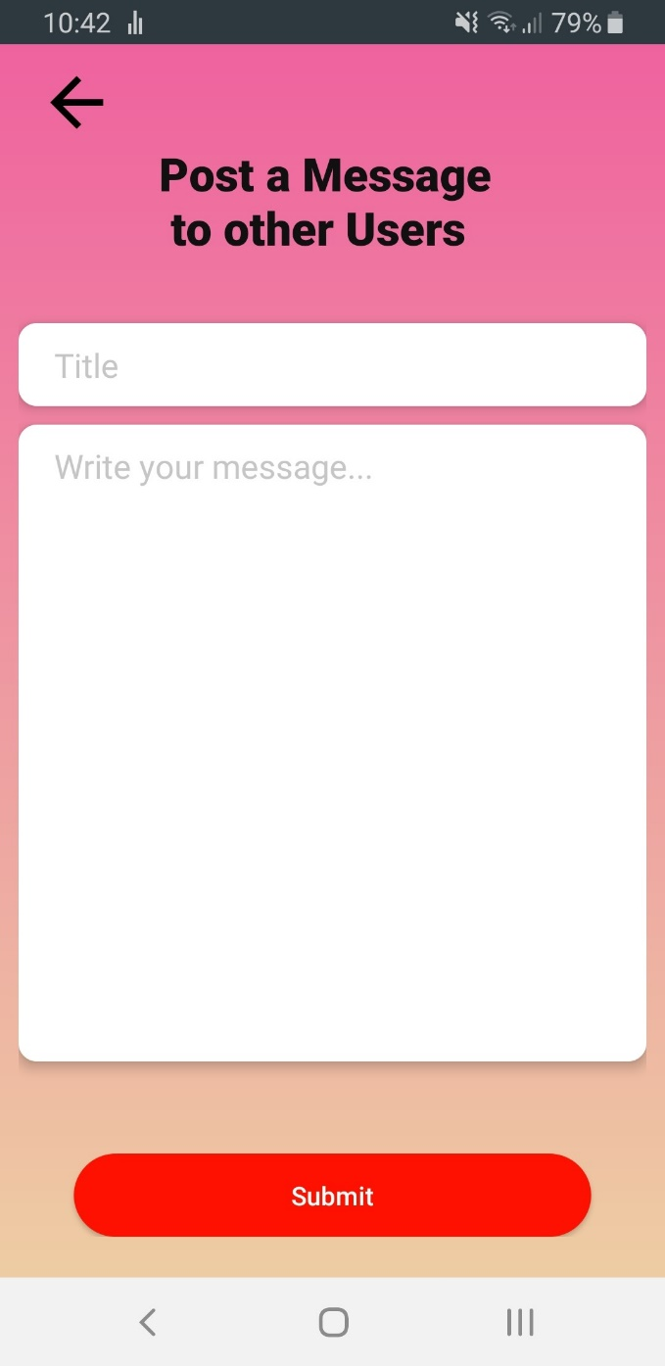

**Add a title for the post**

**Add the contents of the post**

*Note your name, and email will be automatically generated so you don’t have to input that information.

**Click the submit button when finished**

Figure C11

# Workout Log

This feature allows you to track your lifts for each exercise. See Figure C12.

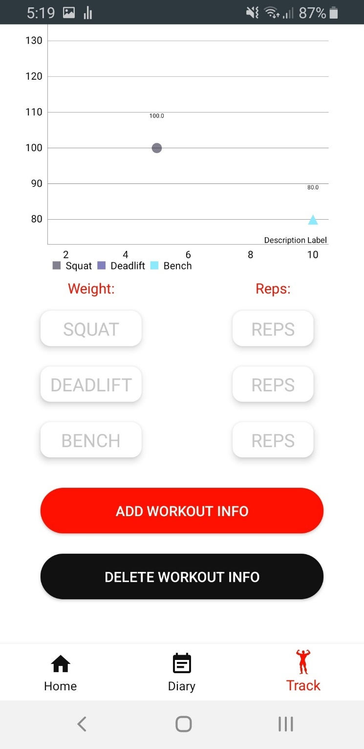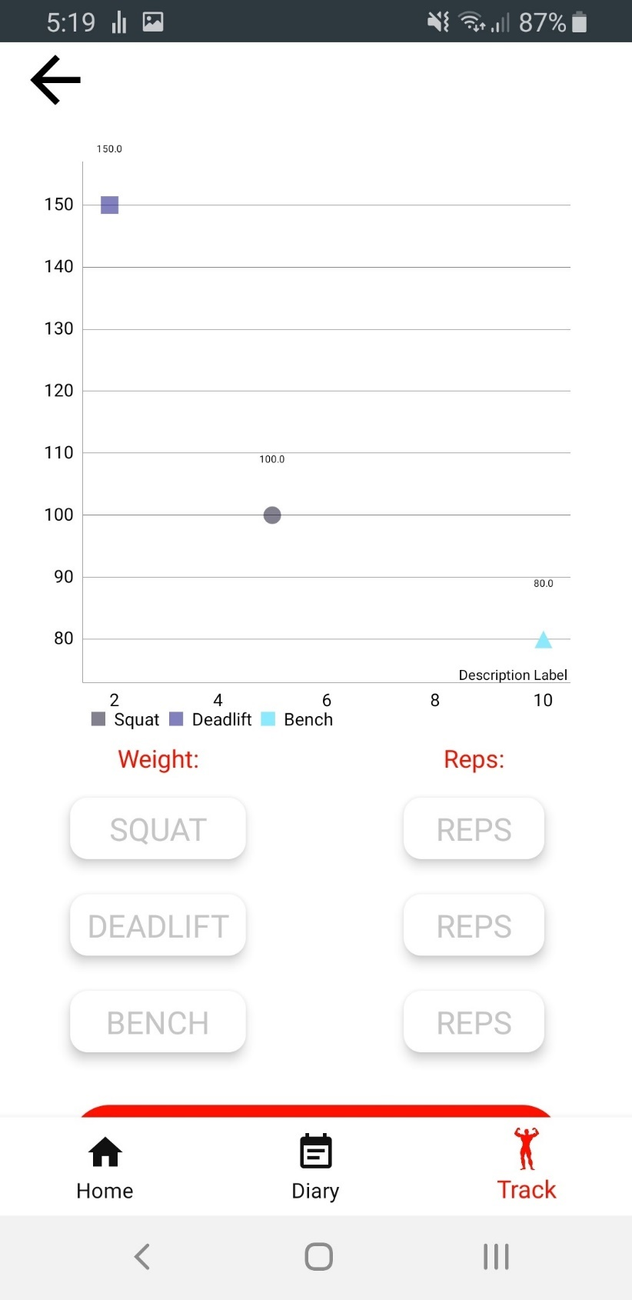

**View the Fully interactive scatter chart. View the weight used, by reps for squat, deadlift and bench press.**

**To reset the graph, delete all the data by clicking the Delete button**

**Input the weight used by reps. When your done, select the Add workout info button**

*Note you must do this for all three exercises.

Figure C12

# Personal Trainer Area

If you created a personal trainer account, you will be able to assign specific workout programs to your clients.

If you do not have a personal trainer account, then you will not be granted access. However, you will be given your unique personal ID. Give this to your Personal trainer, if you have one, and they can assign you a workout.

Figure C13 Shows the PT Area button on the homepage for a regular user. It is replaced the following text. Give the personal key to your personal trainer. Every user will have their own unique key.

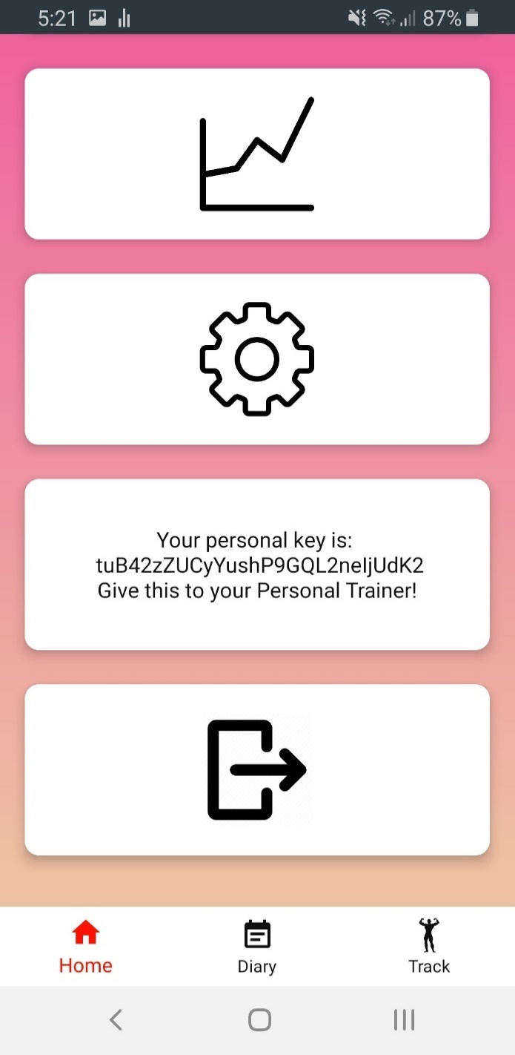

Figure C13

Figure C14 Shows the PT Area for a personal trainer. They will be able to use your key to assign a workout program.

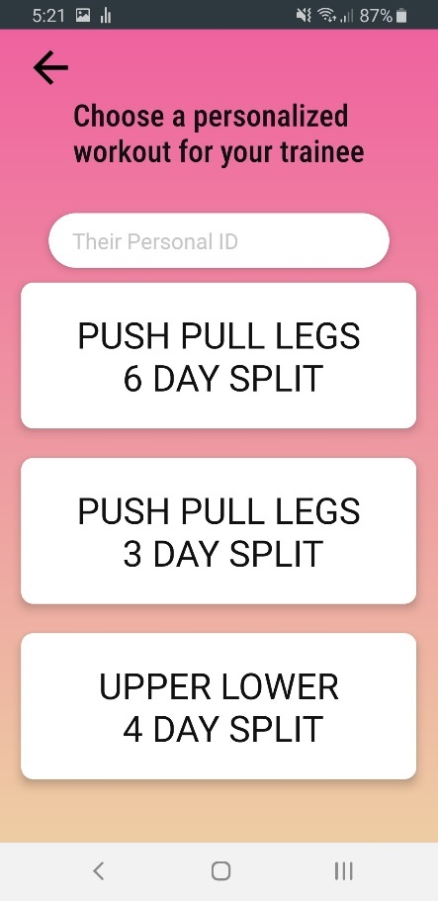

**Input your clients ID**

**Select a Workout program for your client.**

Figure C14

# Settings

To update your details, input what you want to change in the corresponding field.

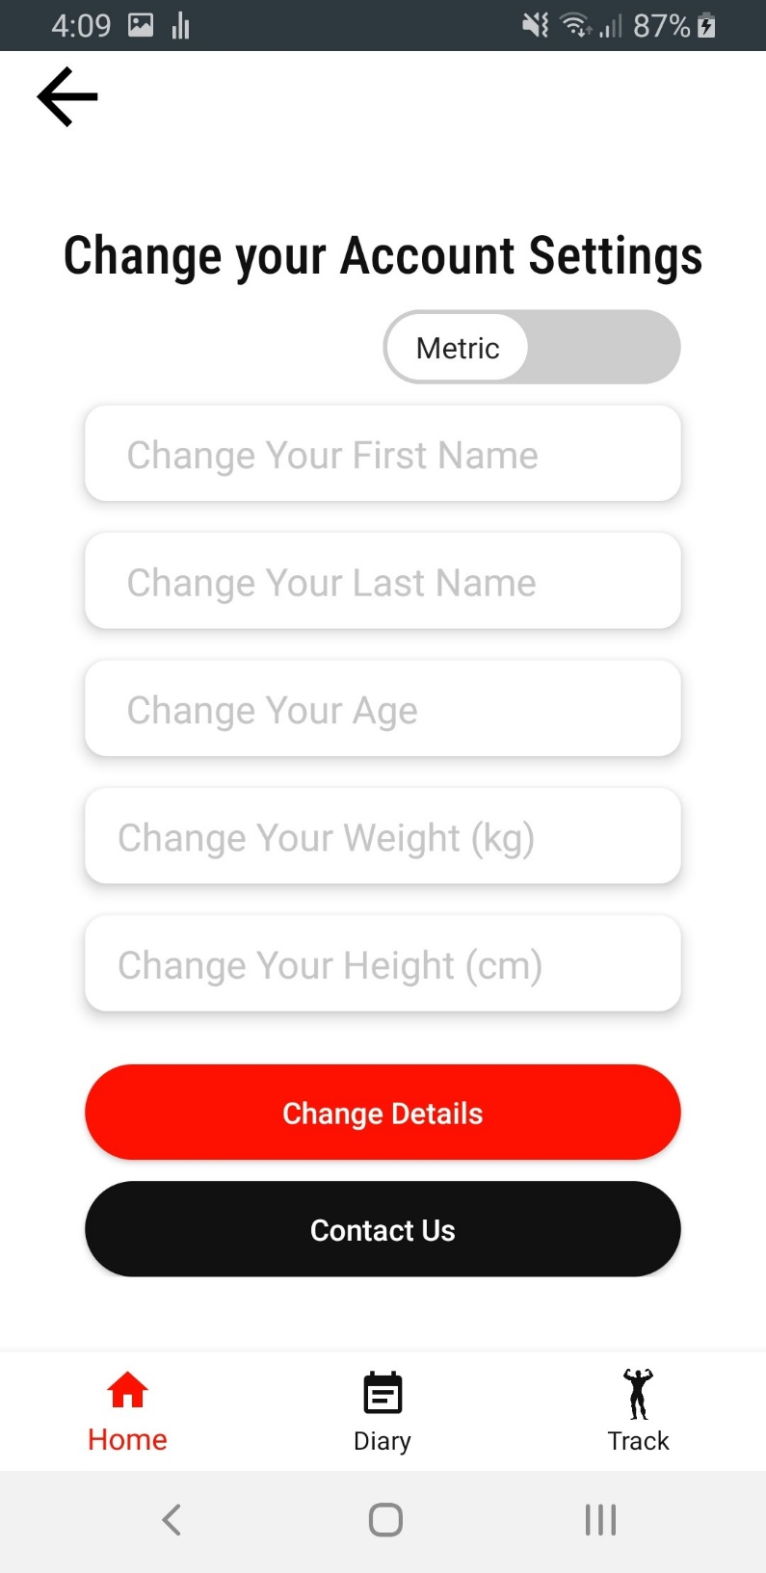

**Switch between the Metric and Imperial system**

**Input the updated details, and select the Change details button**

**Select the Contact us button to send us a message.**

Figure C15

# Contact Us

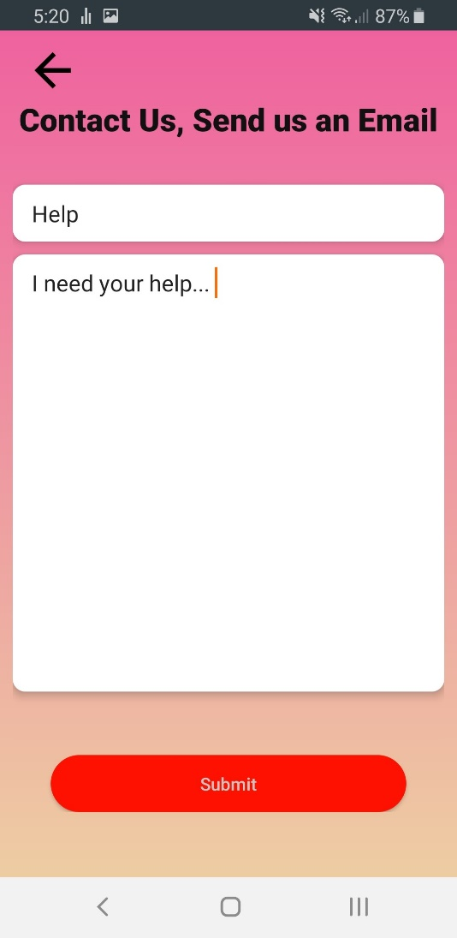To contact us, you will be redirected to a screen to write the message, see Figure C16. Then you will be redirected to your mailing app where you will finalize and send the email.

Figure C16